**PROJECT Bank record loan generation 100 points**

**Objective** To write a program with a MVC ‘simulated’ approach that performs a Loan analysis from class objects created in lab #2.

**PROJECT DESCRIPTION**

Bank of IIT now needs your help in deciphering whom from its records should be exclusive to premium loans versus those offered micro or less premium loans.

Use a database to store then present Loan analysis information from your data BankRecords objects you worked on in prior labs.

**Snapshots of Testcases:**

1. Initiation of BankRecordTest class

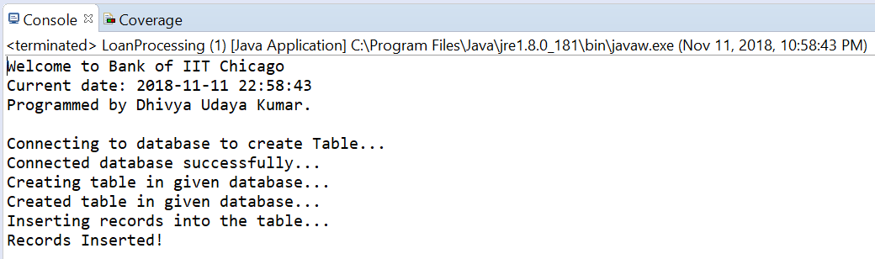

1. JFrame to display the records

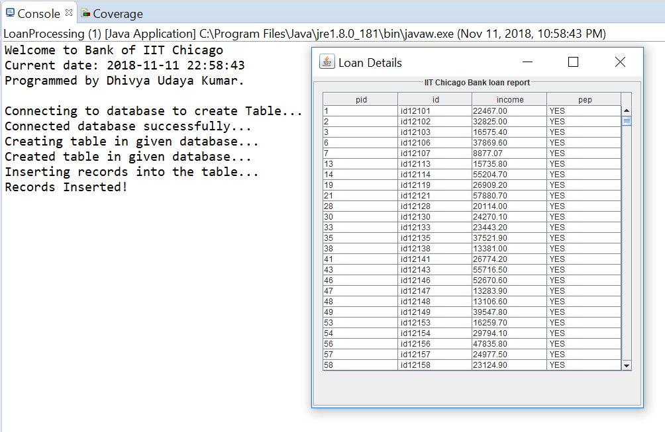

1. Displaying region-wise statistics:

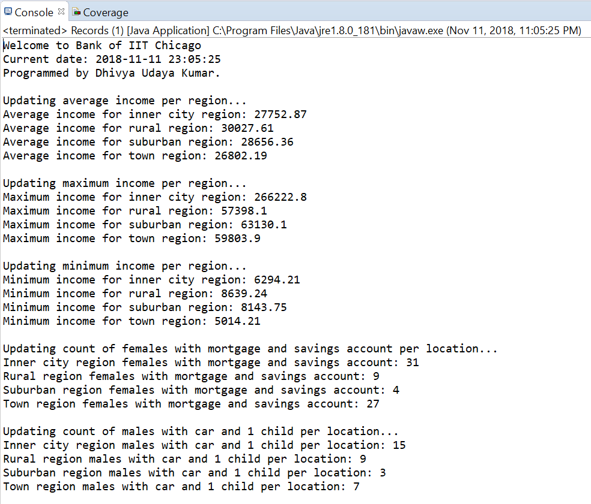

1. Handling empty file exception

